# EXPERIMENT - 07

**Aim: Implement Mid Air Tracking using Vuforia SDK.**

## ABOUT THE EXPERIMENT:

# Introduction to Vuforia Engine

Vuforia is an augmented reality software development kit that supports the development of various augmented reality operations and applications. It primarily uses the computer vision algorithms for the recognition of 2d and 3d objects present in the surroundings.

## 

## Downloading Vuforia SDK

Step 1: Go to <https://developer.vuforia.com/downloads/SDK>

Step 2: Create an account or log in to Vuforia’ Developer Portal.

Step 3: Download the latest version of vuforia unity package.

## 

## Importing Vuforia Package

Step 1: Create a new project in unity.

Step 2: Go to Assets > Import Package > Custom Package.

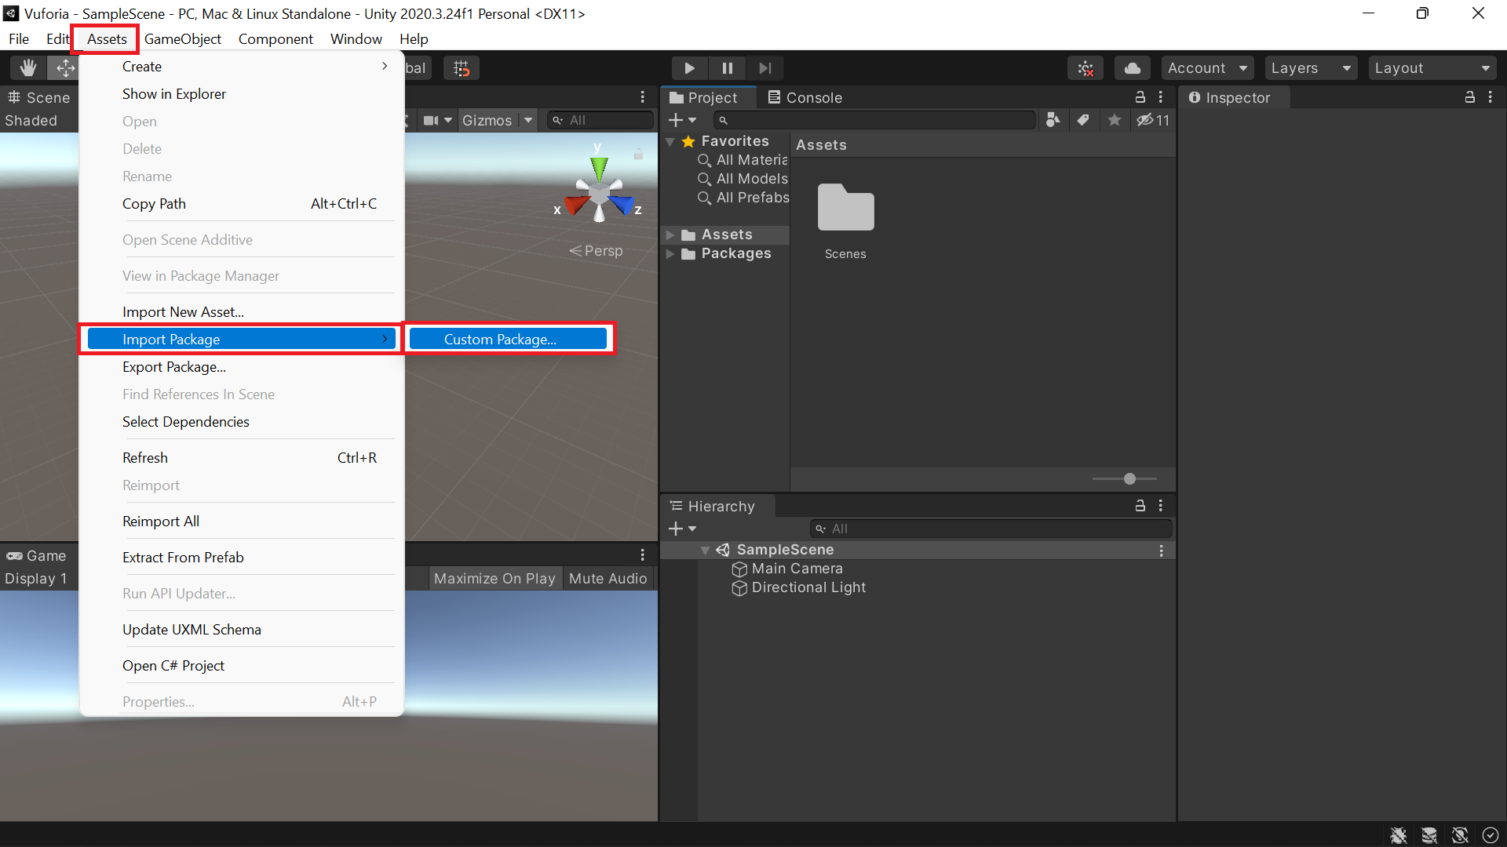

Step 3: Locate the vuforia sdk unity package and click open.

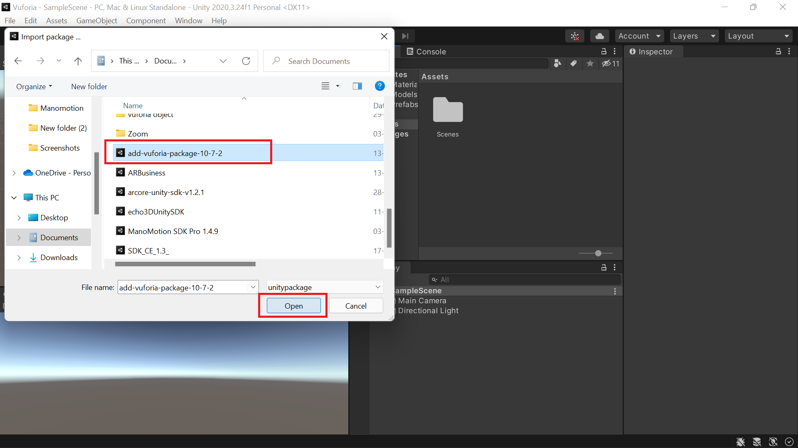

Step 4: Click all, then click import.

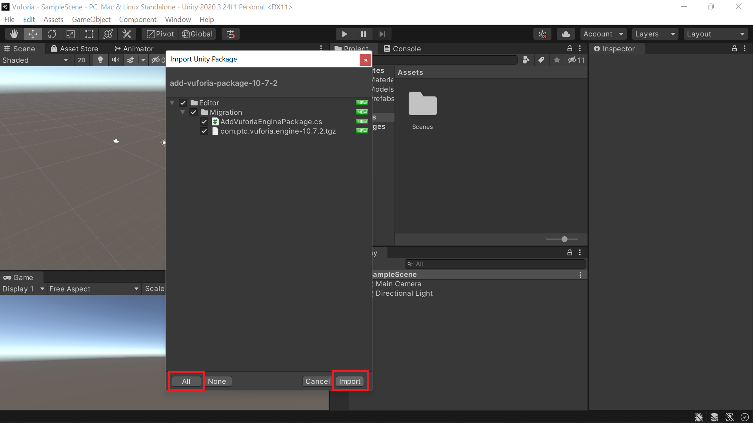

# Steps for Mid Air Tracking

Step 1: Right click the hierarchy window. Navigate to Vuforia Engine and choose AR Camera.

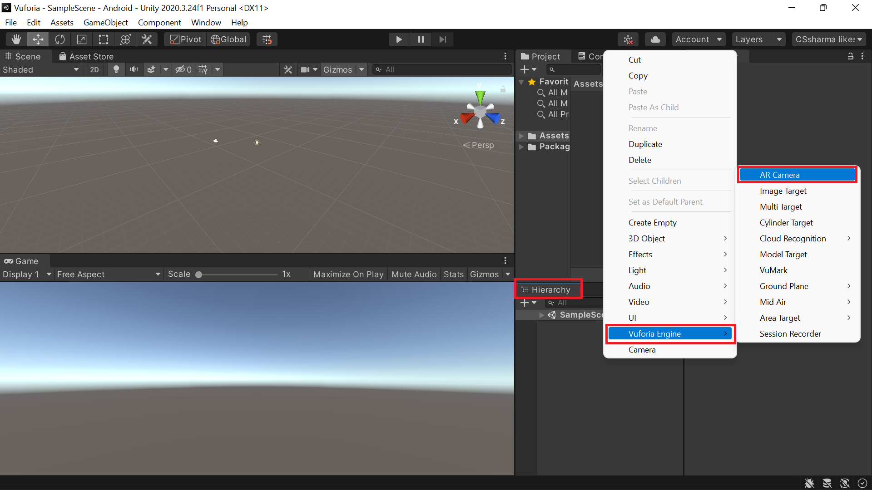

Step 2: Delete the main camera.

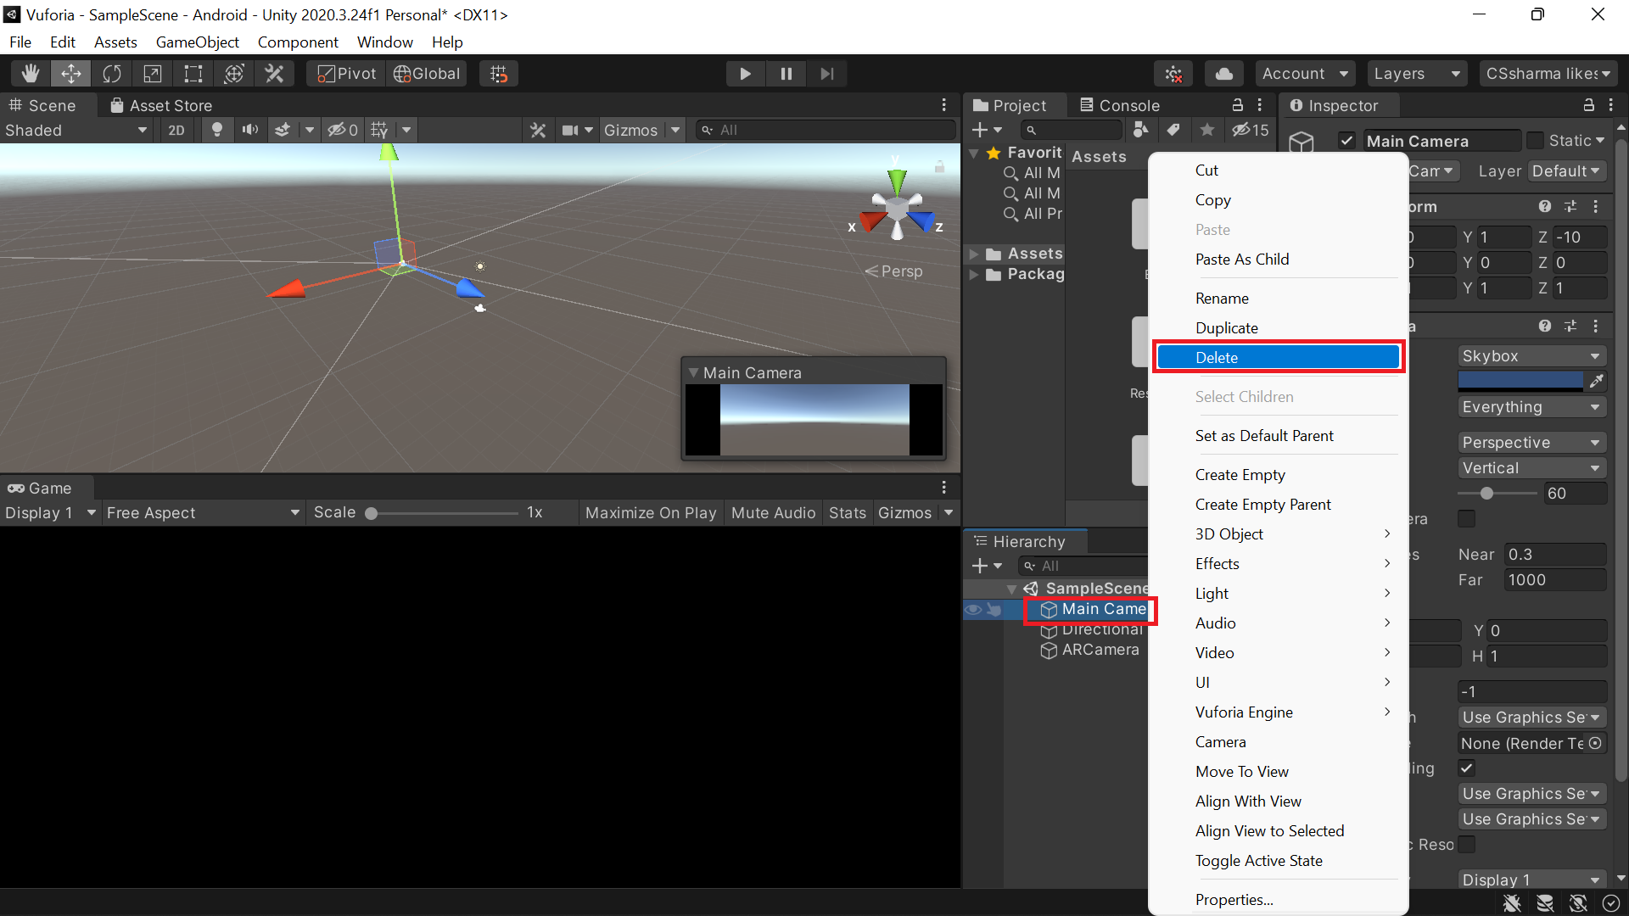

Step 3: Choose AR Camera game object from the heirarchy window and click open vuforia engine configuration.

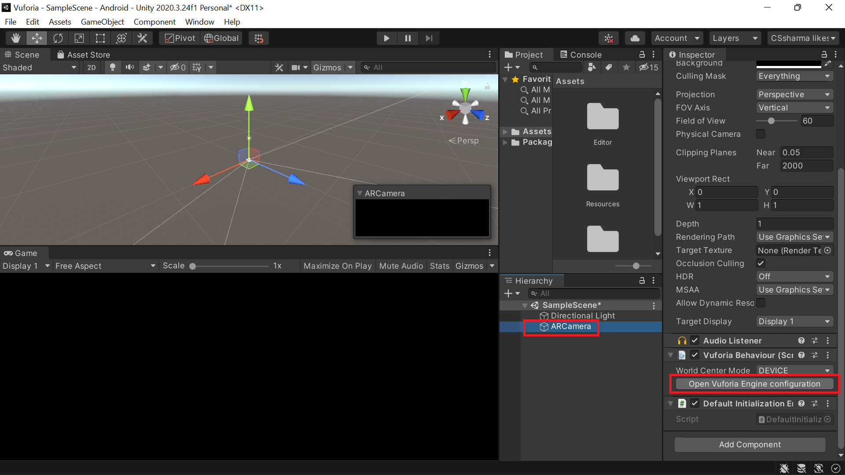

Step 4: Navigate app license key option and click the add license option.

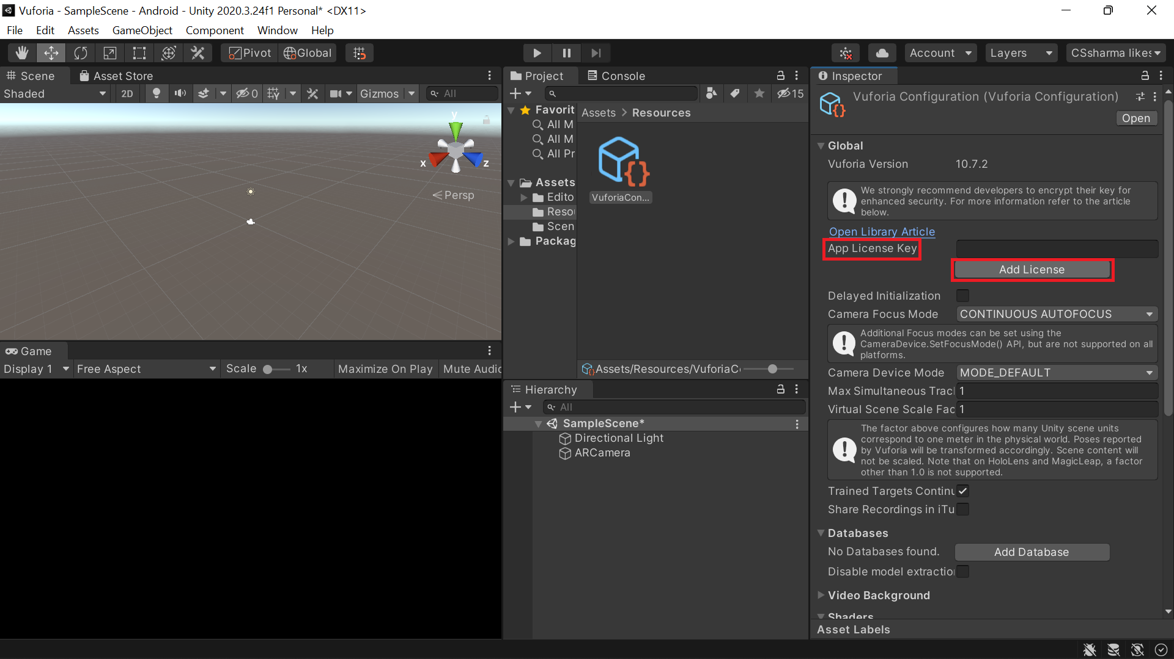

Step 5: Log into your vuforia developer account.

Step 6: In the licence manager pop up window, select the plan you require. In this case, choose get basic.

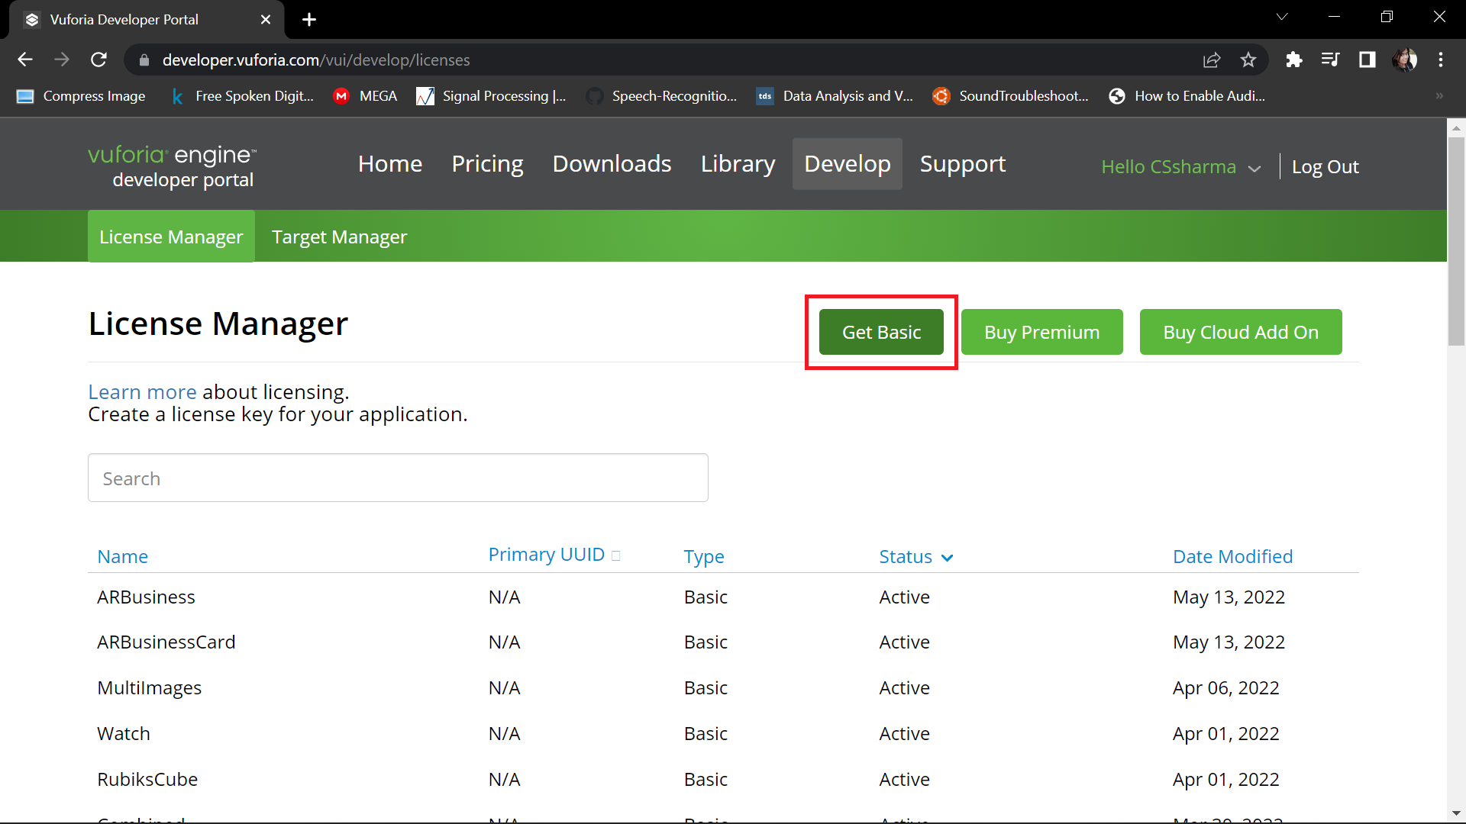

Step 7: Give a name to the licence key. The name can be the name of the project that you are currently working on. Check the acknowlegdement box and click confirm.

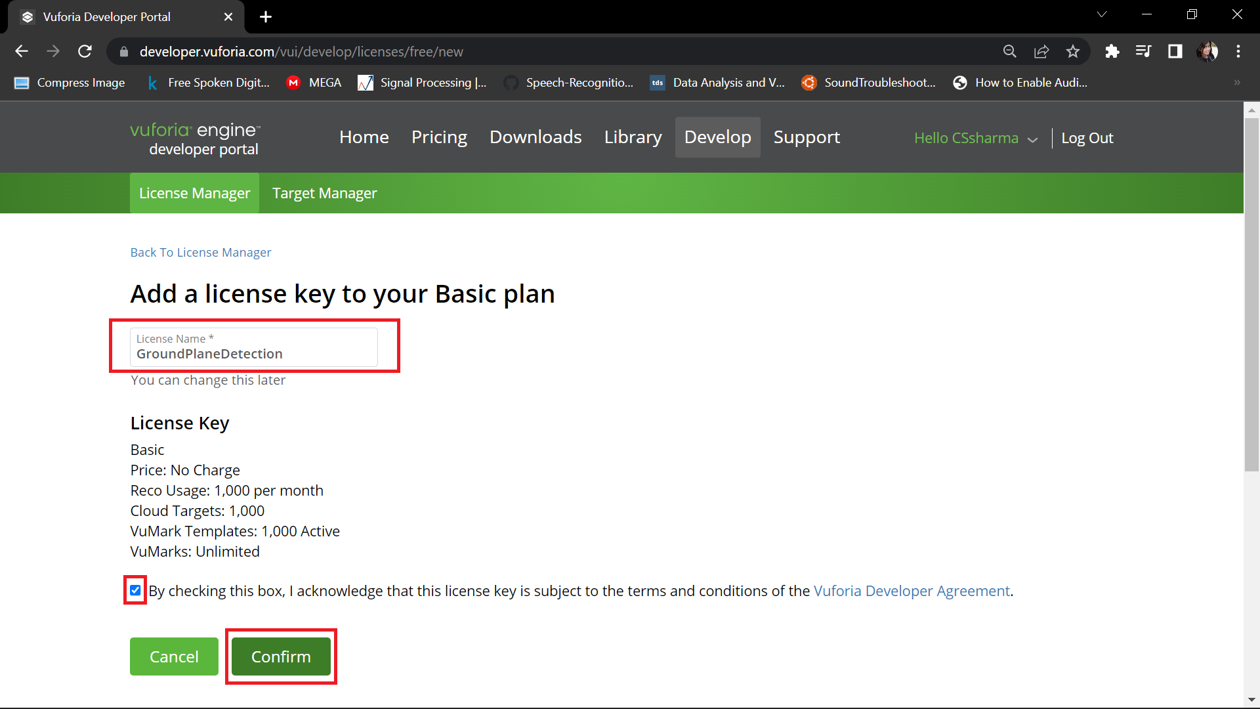

Step 8: Select the licence key genenerated to copy the key on clipboard.

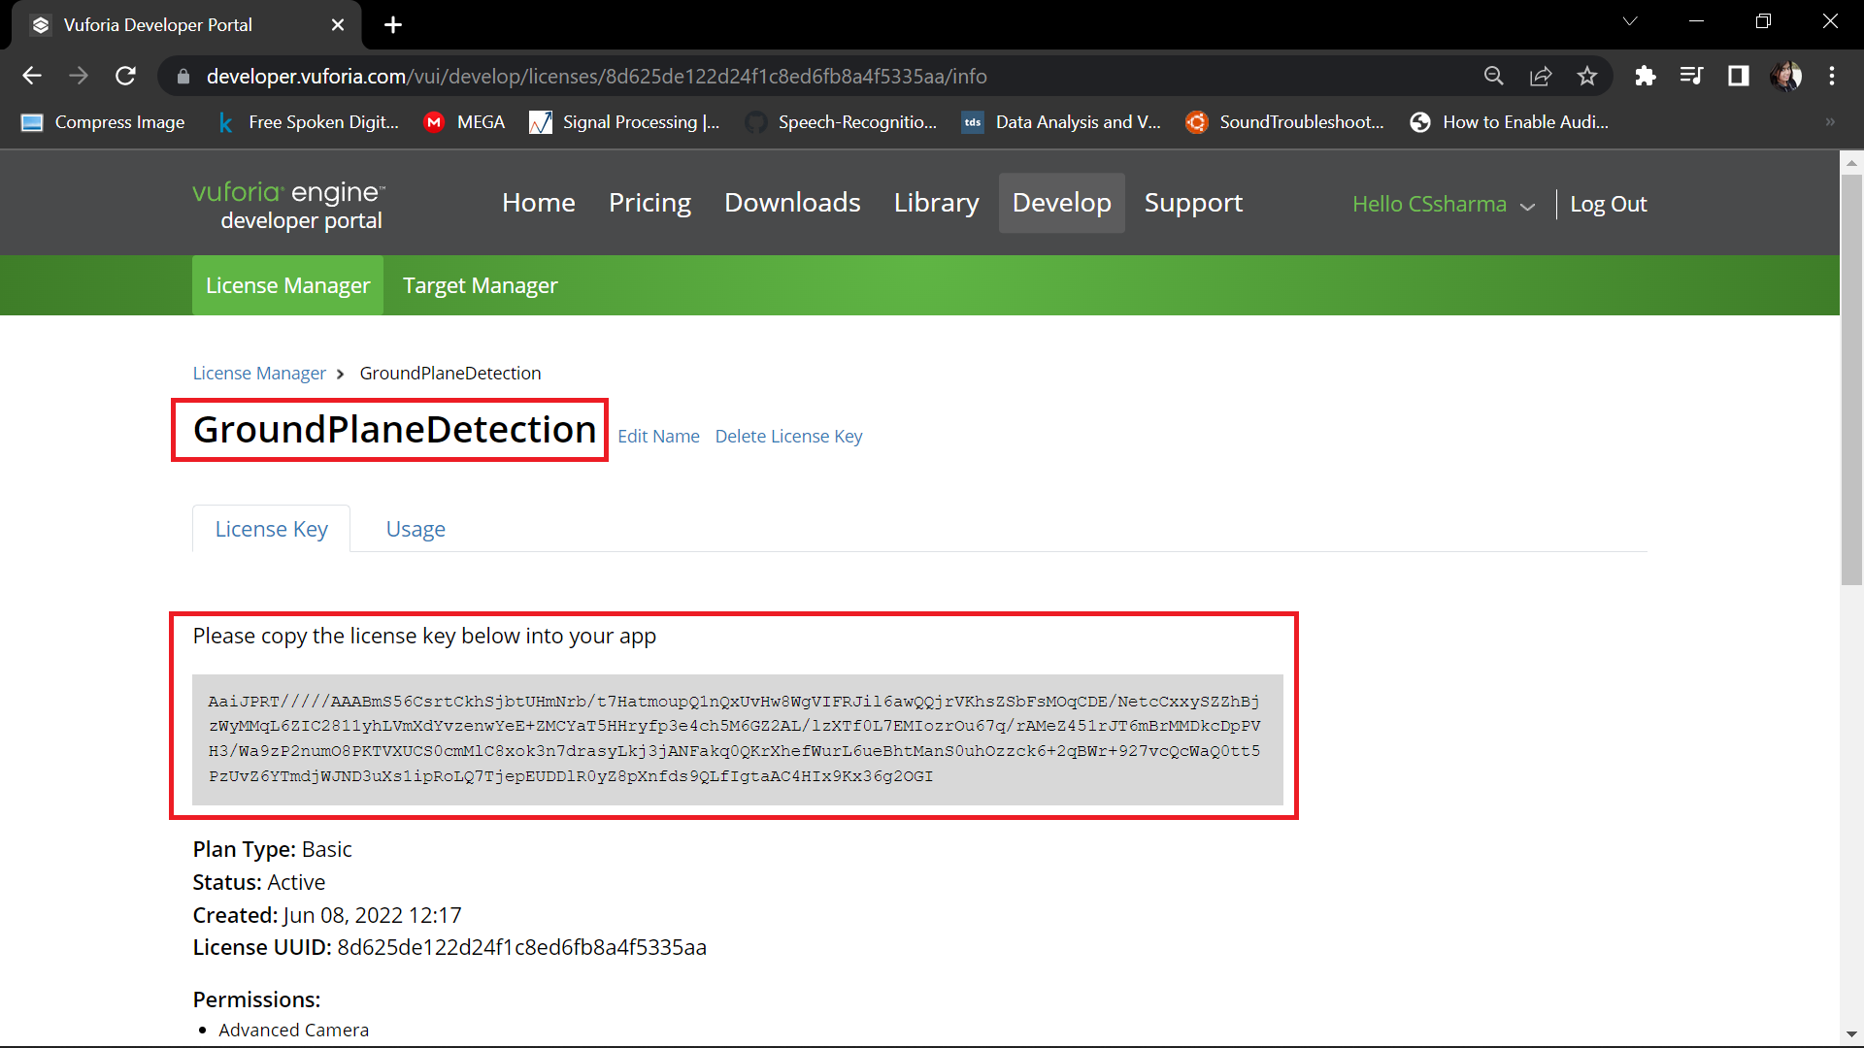

Step 9: Paste the licence key in the app licence key slot in vuforia configuration.

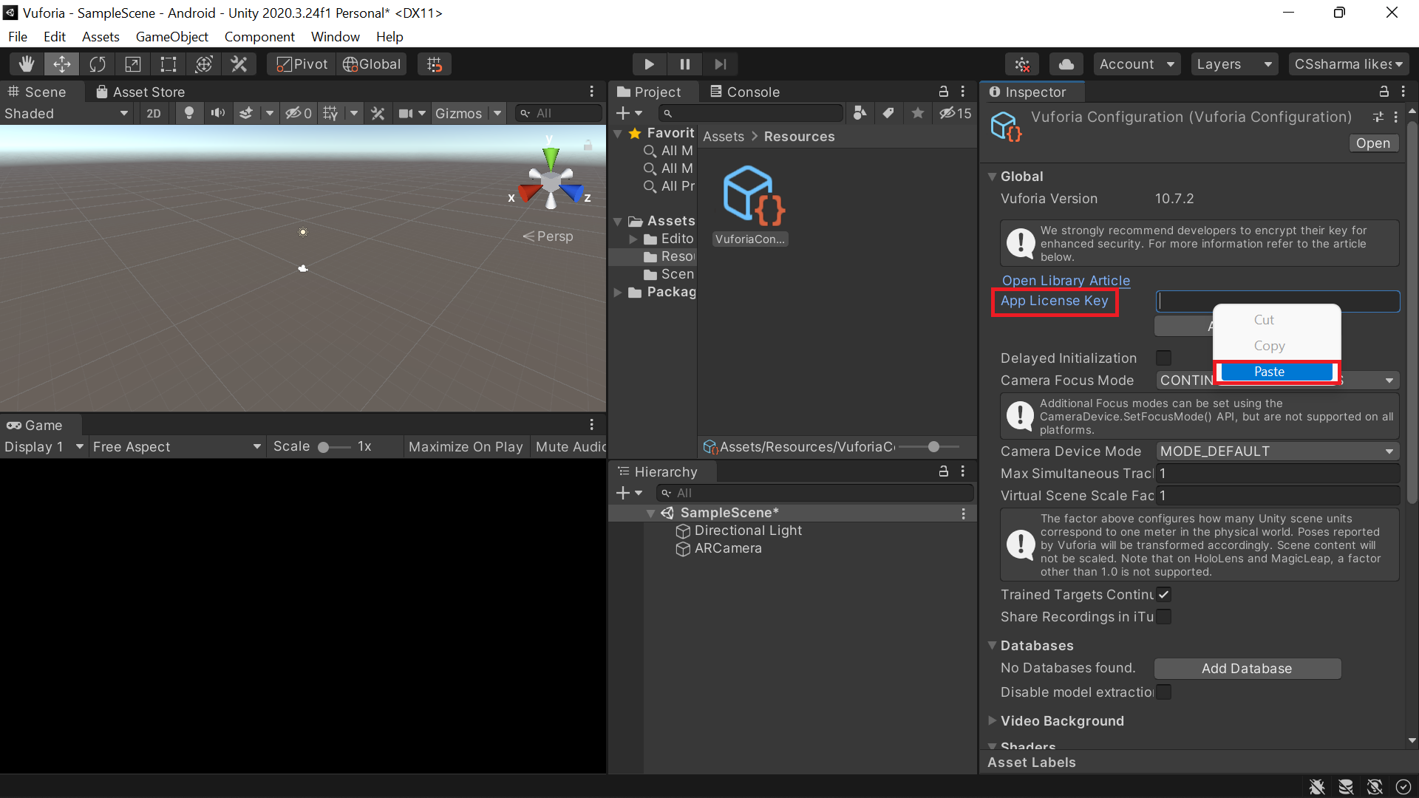

Step 10: Right click in the heirarchy. Select Vuforia Engine > Mid Air > Mid Air Positioner.

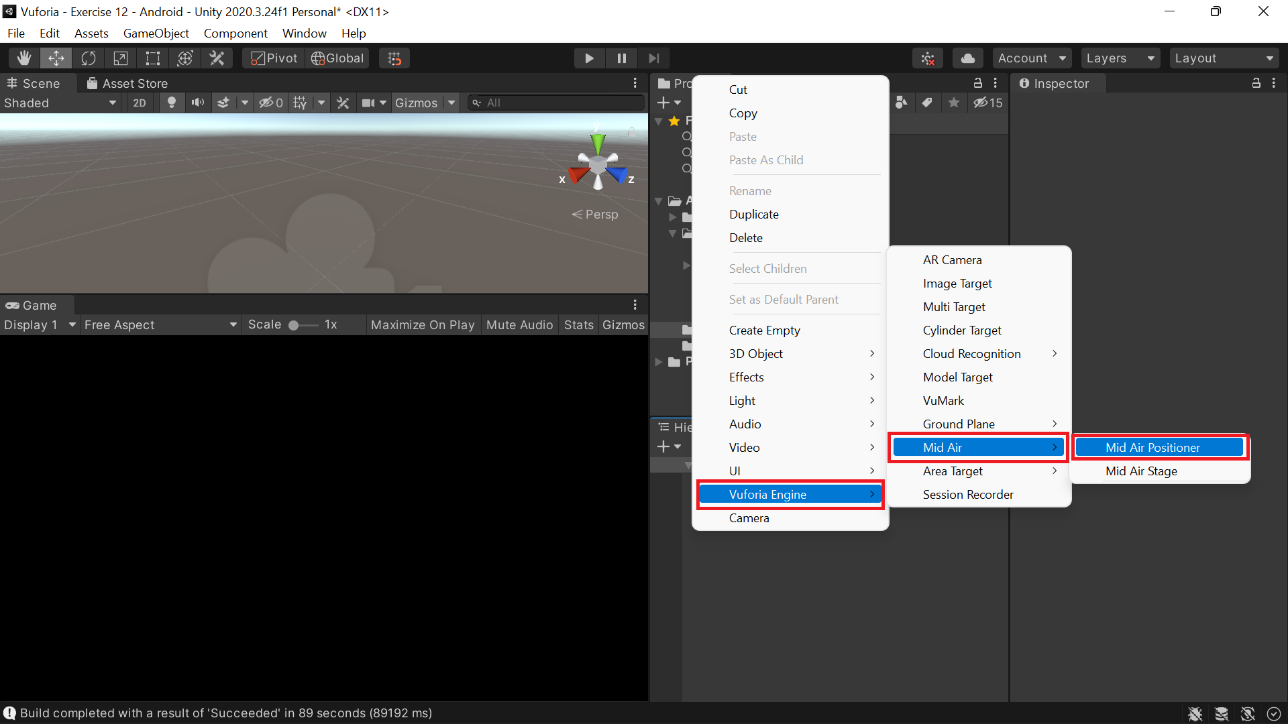

Step 11: Right click in the heirarchy. Select Vuforia Engine > Mid Air > Mid Air Stage.

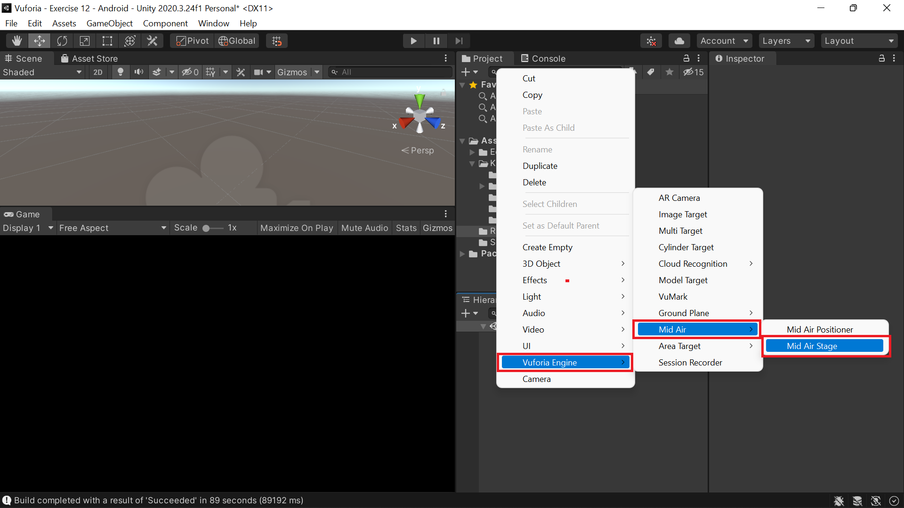

Step 12: Drag and drop the 3D model into the assets folder.

Step 13: Drag and drop the 3D model prefab into the heirarchy window.

Step 14: Make the 3D model prefab a child of the Mid Air Stage game object.

Step 15: Select the Mid Air Positioner game object. Drag and drop the Mid Air Stage game object into the empty anchor stage slot.

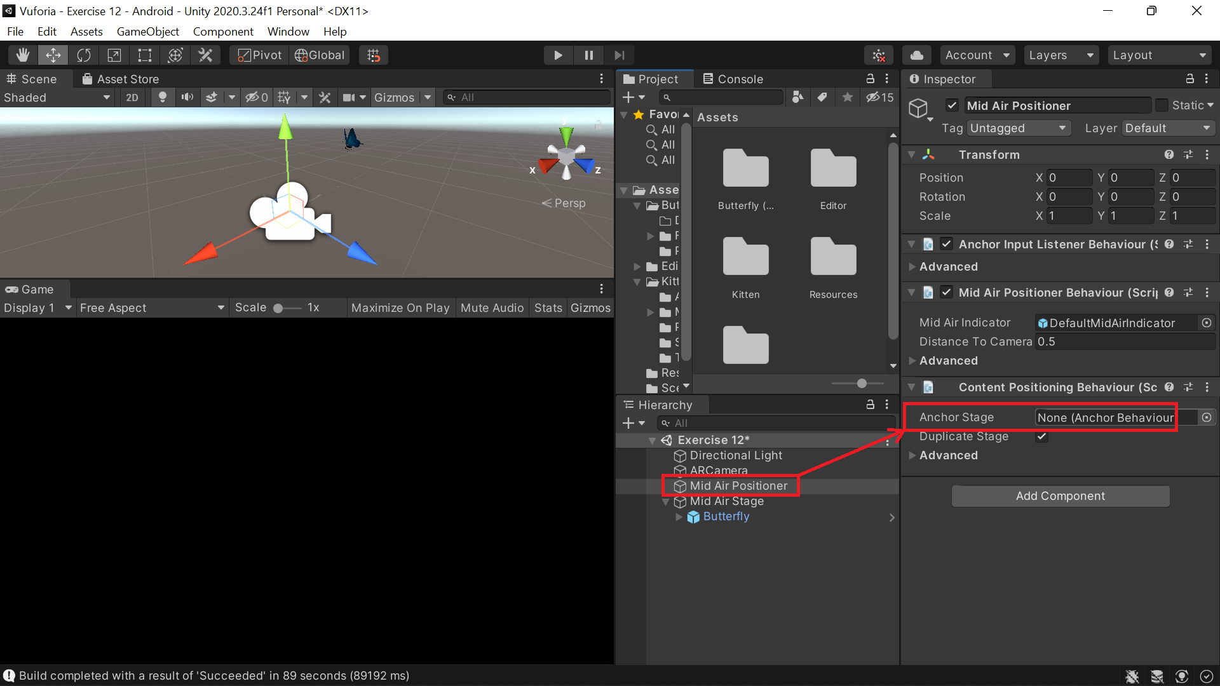

Step 16: Go to File > Build Settings.

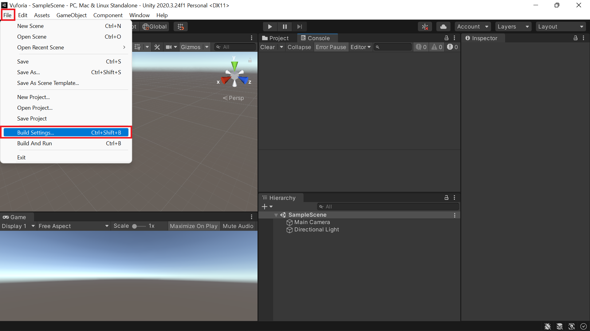

Step 17: Select Android, then click switch platform.

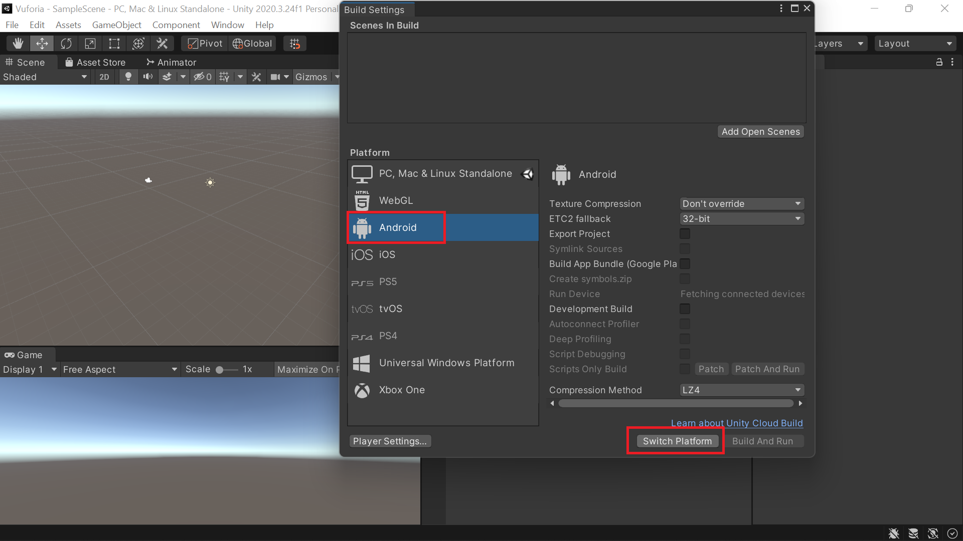

Step 18: Open Player Settings.

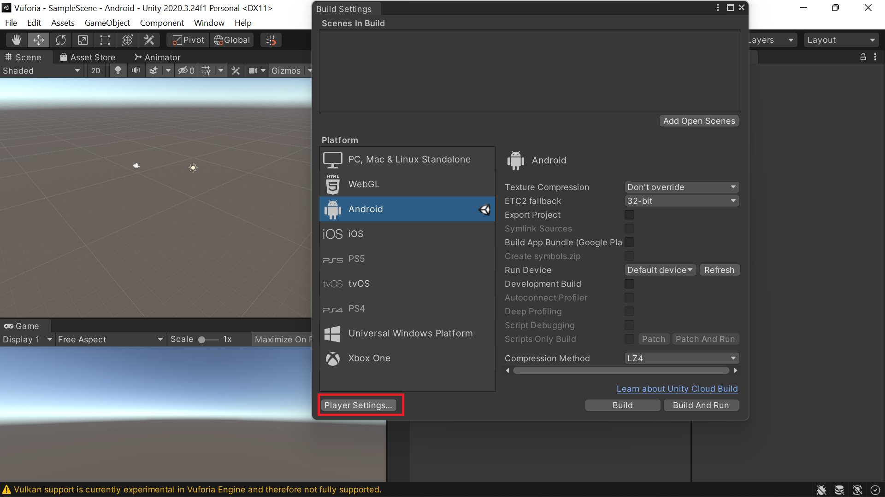

Step 19: Remove Vulkan Graphics.

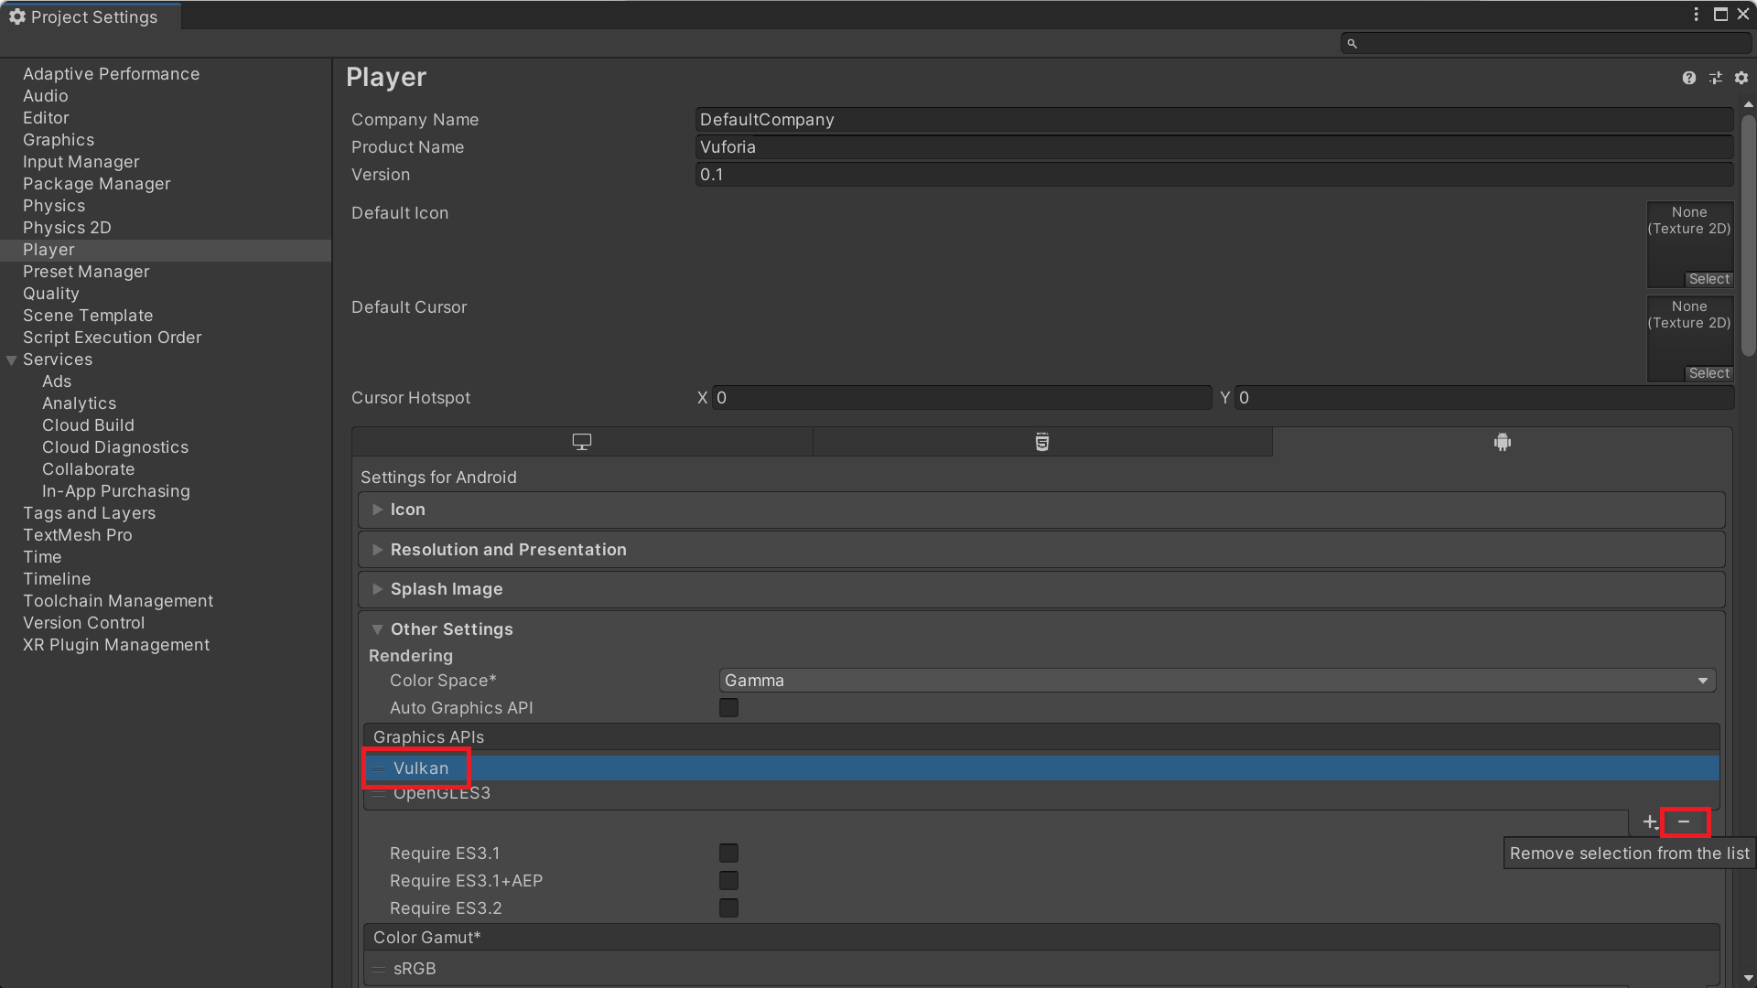

Step 20: Make sure the multithreaded rendering option is unchecked and the minimum api level is set to 24.

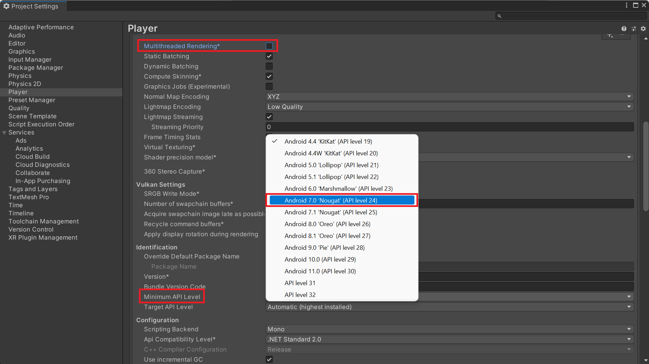

Step 21: Click on File > Build Settings > Add open scenes > Build and run.

Step 22: Make sure the device is connected to the system while building the application. After successful build run and test the application.